**CS-CURE Research Outline**

*Overleaf*

*An Overleaf template is provided for students to copy, containing a research paper LaTeX template project from a recent CS conference.*

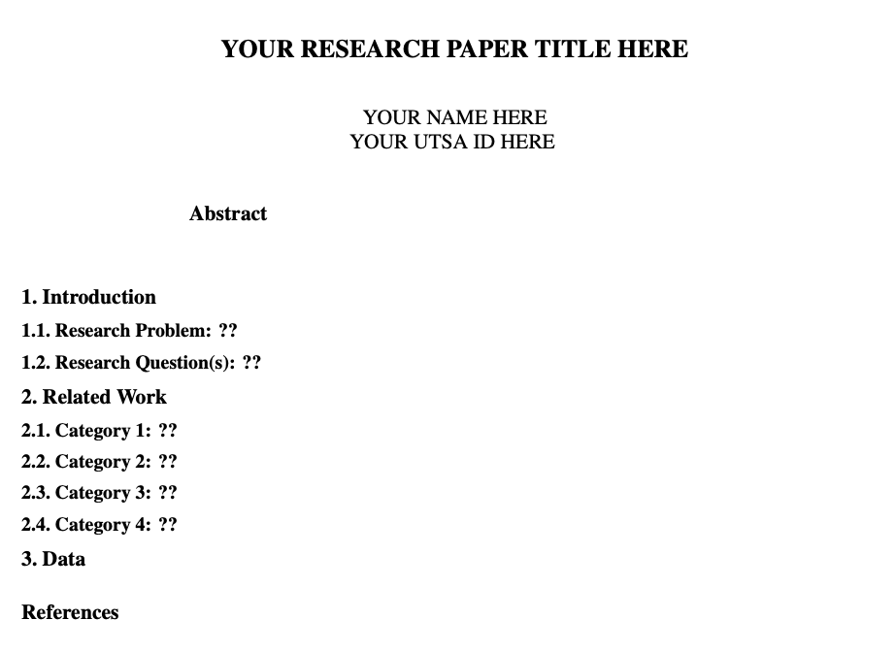

*Instructions are provided in comments in each section:*

* *Abstract: you may leave this blank until the research paper draft deadline*
* ***1. Introduction:***
  + 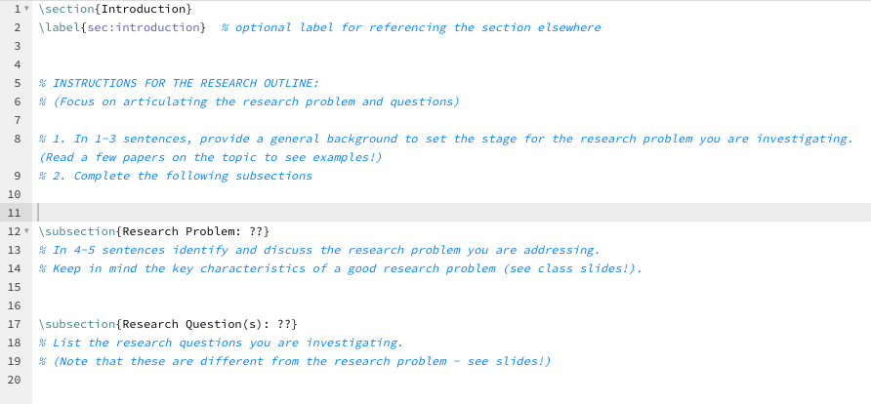
* ***2. Related Work:***
  + 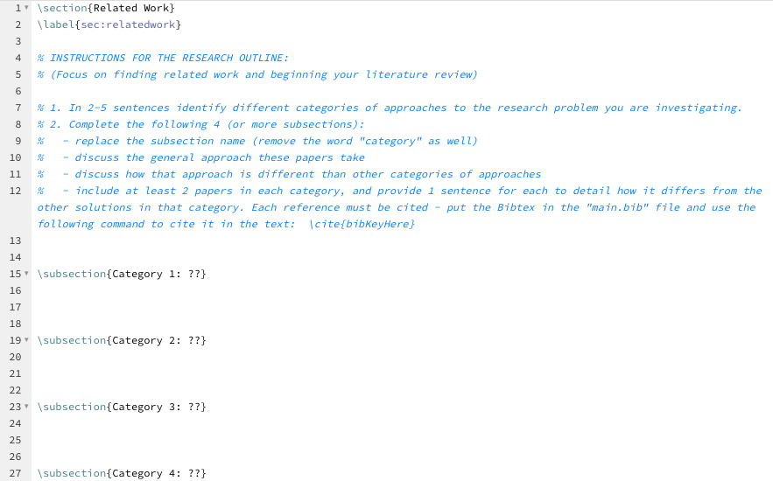
* ***3. Data:***
  + 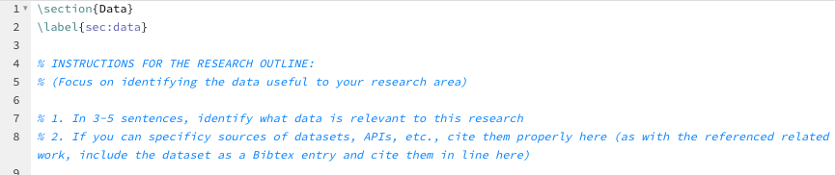

***Grading Rubric:***

